Multiple regression
BMJ 2013; 347 doi: http://dx.doi.org/10.1136/bmj.f4373 (Published 05 July 2013) Cite this as: BMJ 2013;347:f4373 p.sedgwick@sgul.ac.uk
Researchers investigated the association between sleep apnoea and hypertension. A total of 2677 adults, aged 20-85 years, referred to a sleep clinic in Toronto with suspected sleep apnoea syndrome were recruited. Severity of sleep apnoea was measured using the apnoeahypopnoea index, defined as the total number of apnoeic events plus hypopnoeic events divided by the total number of hours of sleep. Blood pressure measurements were averaged across several readings, taken under standard conditions, with the patients awake and supine, just before getting out of bed in the morning.1
Multiple regression was used to examine the association between blood pressure and apnoeahypopnoea index, age, sex, and neck circumference. Separate regression analyses were performed for systolic and diastolic blood pressure (table⇓). Analyses were restricted to 1865 patients not taking antihypertensive drugs.
Multiple linear regression models for blood pressure measurements only in patients not taking antihypertensive drugs (n=1865)
Independent variables | Systolic blood pressure |  | Diastolic blood pressure
Independent variables | β (95% CI) | P value | β (95% CI) | P value
Apnoea-hypopnoea index (1 apnoeic event) | 0.10 (0.07 to 0.13) | 0.0001 | 0.07 (0.05 to 0.09) | 0.0001
Age (1 year) | 0.39 (0.34 to 0.44) | 0.0001 | 0.21 (0.17 to 0.24) | 0.0001
Sex (male) | −0.70 (−2.50 to 1.11) | 0.45 | 2.05 (0.86 to 3.24) | 0.0007
Neck circumference (1 cm) | 1.01 (0.80 to 1.21) | 0.0001 | 0.47 (0.33 to 0.61) | 0.0001

Which of the following statements, if any, are true?
a) Systolic and diastolic blood pressures were assumed to be linearly related to each of apnoea-hypopnoea index, age, and neck circumference
b) It can be concluded that the effect of the apnoea-hypopnoea index was independently associated with systolic and diastolic blood pressure in patients with apnoea not taking antihypertensive drugs
c) The results of the analyses can be extrapolated outside the observed range of values for apnoeahypopnoea index, age, and neck circumference
d) The results of the analyses can be generalised to all patients referred to the sleep clinic with suspected sleep apnoea

Multiple Linear Regression Example:

We have data on forced expiratory volume (FEV) on 654 children, ages 3-19 from Boston MA. FEV is the volume of air expelled after one second of constant effort (liters). Additionally, we have measurements for height (inches), age (years), smoking status and sex.

Simple Statistics

Variable N Mean Std Dev Sum Minimum Maximum

fev 654 2.63678 0.86706 1724 0.79100 5.79300
age 654 9.93119 2.95394 6495 3.00000 19.00000
height 654 61.14358 5.70351 39988 46.00000 74.00000
smoke 654 0.09939 0.29941 65.00000 0 1.00000

Pearson Correlation Coefficients, N = 654
Prob > |r| under H0: Rho=0

fev age height smoke

fev 1.00000 0.75646 0.86814 0.24542
<.0001 <.0001 <.0001

age 0.75646 1.00000 0.79194 0.40425
<.0001 <.0001 <.0001

height 0.86814 0.79194 1.00000 0.28039
<.0001 <.0001 <.0001

smoke 0.24542 0.40425 0.28039 1.00000
<.0001 <.0001 <.0001

A model of FEV including smoking, age and height is:

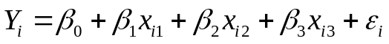

Where β₀ = _______________
This is written for the ith subject, we could write the model for all subjects as:

β₁ = ____________________ and x₁ =

β₂ = ____________________ and x₂ =

β₃ = ____________________ and x₃ =

Y_{i} is ___________________________.

The errors, ε ~ i.i.d. N(0, σ²)
What are some potential research questions?

What are some potential modelling issues?

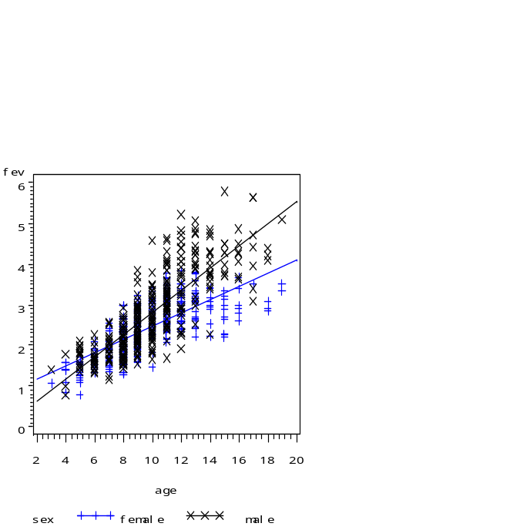 | 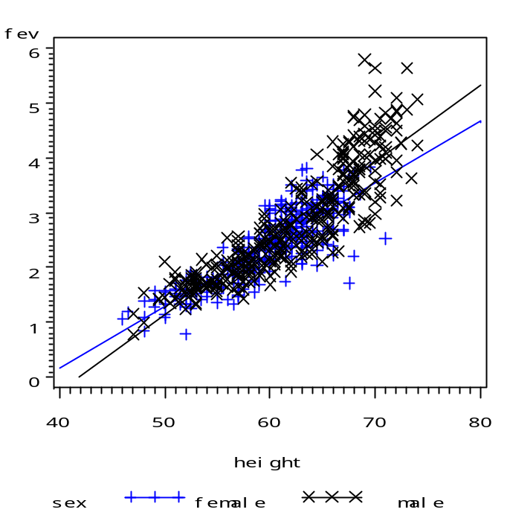
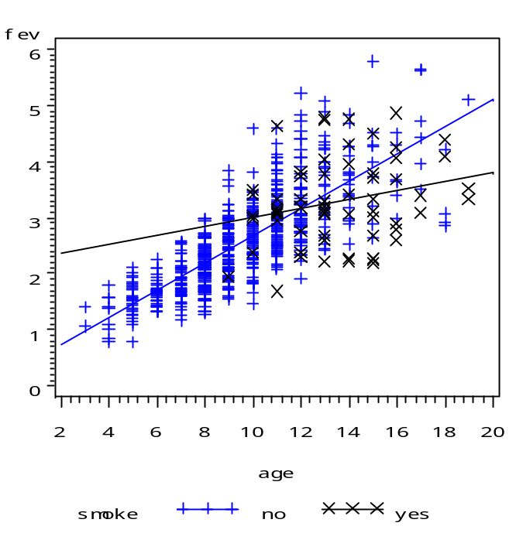 | 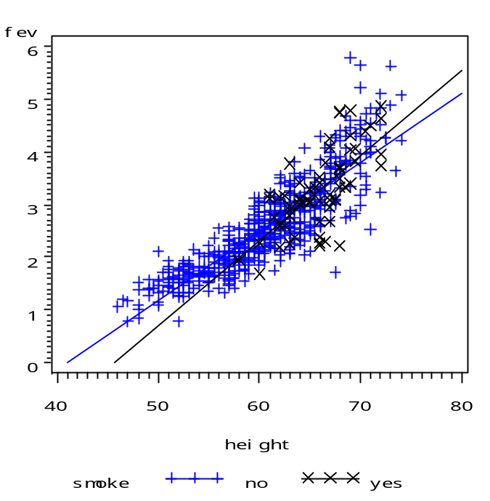

SAS PROC GLM output
Dependent Variable: fev

R-Square Coeff Var Root MSE fev Mean
0.060233 31.90198 0.841185 2.636780

Source DF Type III SS Mean Square F Value Pr > F
smoke 1 29.56968252 29.56968252 41.79 <.0001

Standard
Parameter Estimate Error t Value Pr > |t|

Intercept 3.276861538 B 0.10433616 31.41 <.0001
smoke 0 -0.710718924 B 0.10994262 -6.46 <.0001
smoke 1 0.000000000 B . . .

smoke fev LSMEAN

0 2.56614261
1 3.27686154

1. The above is a t-test (even though it was run using a regression procedure, GLM), testing what?

2. What are your conclusions based on this analysis?

3. Interpret the coefficient for smoking.

Dependent Variable: fev
Sum of
Source DF Squares Mean Square F Value Pr > F
Model 4 380.6402823 95.1600706 560.02 <.0001
Error 649 110.2795540 0.1699223
Corrected Total 653 490.9198363

R-Square Coeff Var Root MSE fev Mean
0.775361 15.63332 0.412216 2.636780

Source DF Type III SS Mean Square F Value Pr > F
height 1 81.50494212 81.50494212 479.66 <.0001
age 1 8.09947191 8.09947191 47.67 <.0001
smoke 1 0.36839780 0.36839780 2.17 0.1414
sex 1 3.80327822 3.80327822 22.38 <.0001

Standard
Parameter Estimate Error t Value Pr > |t|

Intercept -4.387117360 B 0.23979870 -18.30 <.0001
height 0.104199428 0.00475772 21.90 <.0001
age 0.065509323 0.00948855 6.90 <.0001
smoke 0 0.087246393 B 0.05925352 1.47 0.1414
smoke 1 0.000000000 B . . .
sex 0 -0.157102930 B 0.03320706 -4.73 <.0001
sex 1 0.000000000 B . .

The GLM Procedure
Least Squares Means

smoke fev LSMEAN

0 2.64328913
1 2.55604273
1. Note the changes in R² and the means for smoking.

2. Do your conclusions from above change?

3. Interpret the coefficient for smoking.

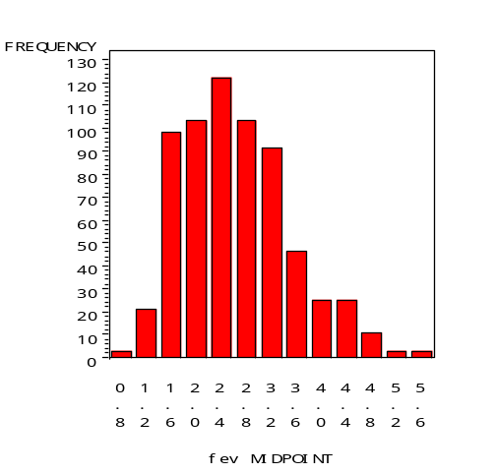 | 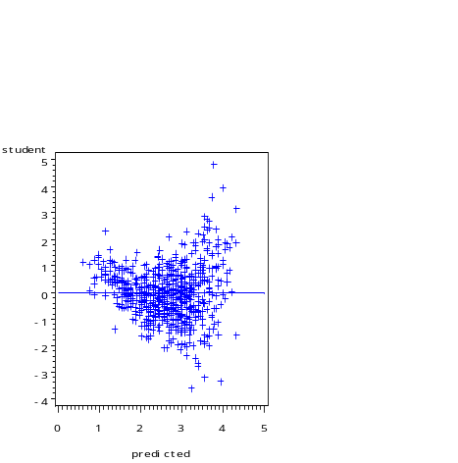

Logging will help fix_________________________________________________________.

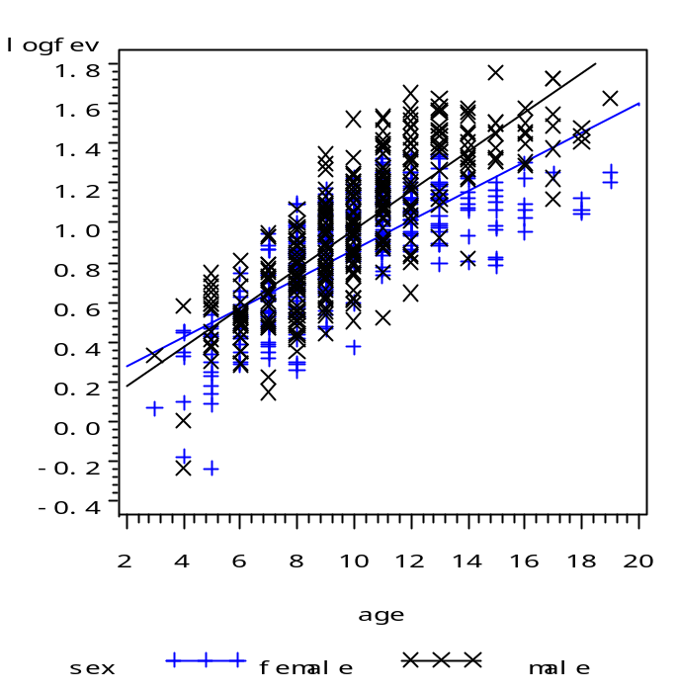 | 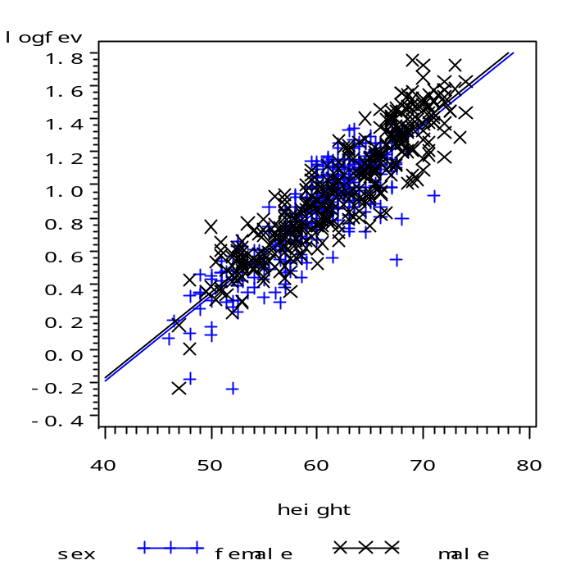
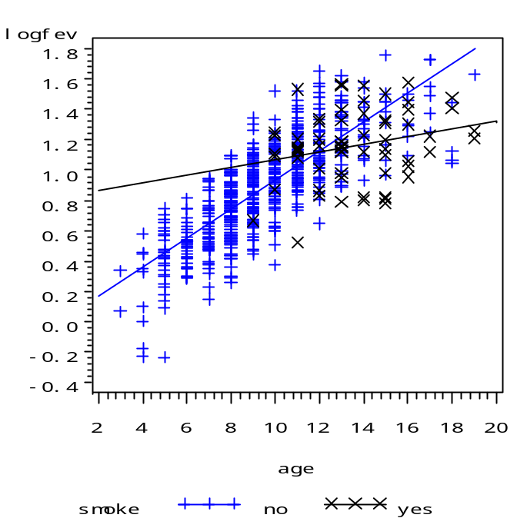 | 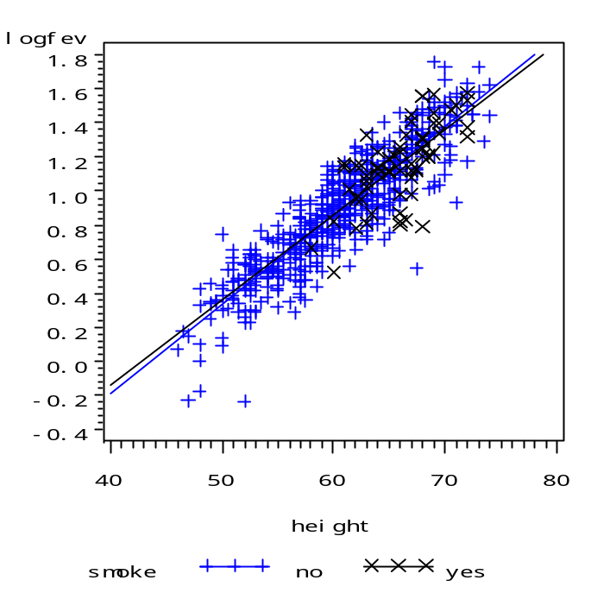
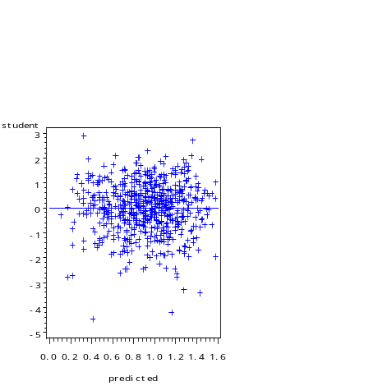 | 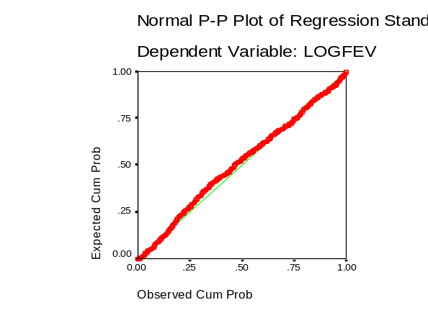

Take logarithm of FEV to take care of problems with 1. normality of Y (and therefore errors) 2. non-constant variance and 3. Nonlinearity

However, using the log transform can reduce the interpretability of the model.

The GLM Procedure

Dependent Variable: logfev

Sum of
Source DF Squares Mean Square F Value Pr > F

Model 4 58.79235724 14.69808931 694.58 <.0001

Error 649 13.73355763 0.02116111

Corrected Total 653 72.52591487

R-Square Coeff Var Root MSE logfev Mean

0.810639 15.89062 0.145469 0.915437

Source DF Type III SS Mean Square F Value Pr > F

height 1 13.74850096 13.74850096 649.71 <.0001
age 1 1.03230364 1.03230364 48.78 <.0001
sex 1 0.13246418 0.13246418 6.26 0.0126
smoke 1 0.10270983 0.10270983 4.85 0.0279

Standard
Parameter Estimate Error t Value Pr > |t|

Intercept -1.960746354 B 0.08462347 -23.17 <.0001
height 0.042795789 0.00167897 25.49 <.0001
age 0.023387214 0.00334845 6.98 <.0001
sex 0 -0.029319358 B 0.01171856 -2.50 0.0126
sex 1 0.000000000 B . . .
smoke 0 0.046067536 B 0.02091020 2.20 0.0279
smoke 1 0.000000000 B . . .
Note: 0=female/1=male

1. How did R² change?

2. How do conclusions change?

3. Interpret the coefficient for smoking.

